📊 ETL Pipeline for Financial Risk Data (Dashboard Guideline).docx
Executive Summary
The Basel III Dashboard is the final deliverable of the ETL Pipeline for Financial Risk Data project. It consolidates outputs from the Installation, Schema, and Automation layers into a simple visualization. Executives can monitor compliance and resilience at a glance, with traffic-light indicators and ratio charts that highlight deviations from Basel III requirements.

1. Dashboard Structure (FS10)
The dashboard presents a consolidated table of CAR, LCR, NSFR, CET1, and leverage ratios. Traffic-light indicators (green/yellow/red) highlight compliance status.
import pandas as pd
import matplotlib.pyplot as plt

# Load the CSV file (produced by automation or seeded manually)
df = pd.read_csv("basel_ratios.csv")

# Add compliance flags
df['Compliance'] = df['Ratio'].apply(lambda x: 'Green' if x >= 100 else 'Red')

# Print table
print(df[['RatioName','Ratio','Compliance']])

2. Visualization Layer (FS11)
Ratios are plotted as bar charts with thresholds marked. This makes deviations from Basel III requirements immediately visible.
plt.bar(df['RatioName'], df['Ratio'],
color=['green' if c == 'Green' else 'red' for c in df['Compliance']])
plt.axhline(y=100, color='black', linestyle='--', label='Threshold')
plt.legend()
plt.title("Basel III Ratios Dashboard")
plt.show()

3. Static Output (FS12)
This dashboard is not interactive. It is a static visualization sourced from a small CSV file. The purpose is to demonstrate compliance status clearly, not to provide user controls or dynamic filtering.

4. Integration with Automation Outputs (FS13)
The dashboard consumes reconciled datasets produced by the Automation Guideline. In practice, the CSV file (basel_ratios.csv) is generated by the ETL pipeline and ratio automation modules, ensuring consistency between data preparation and visualization.

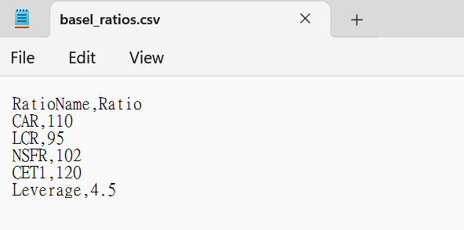

Program Output:

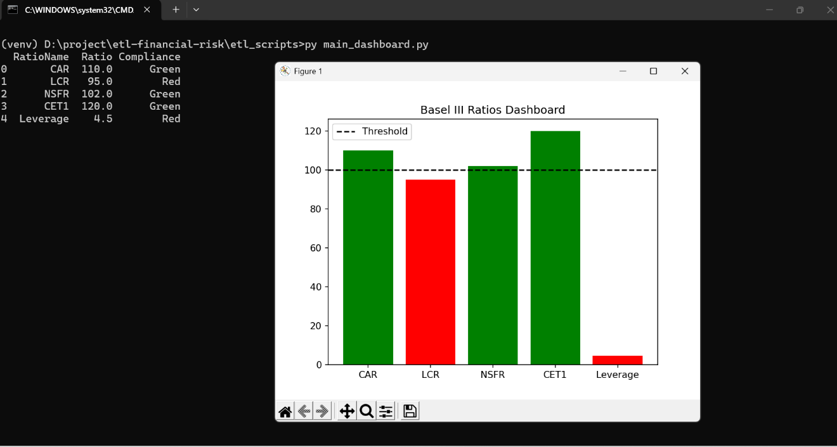
Conclusion
The dashboard is the final deliverable, combining automation outputs into a clear, static interface. It demonstrates compliance, resilience, and performance in a format accessible to decision-makers. Together with the Installation, Schema, and Automation Guidelines, this document completes the ETL Pipeline for Financial Risk Data project.

